**Assessment Task 3- Reflective Essay**

**Gianni Pessotto**

**University of Technology Sydney**

**Tutor:**

**John English**

**Student ID:**

**13199219**

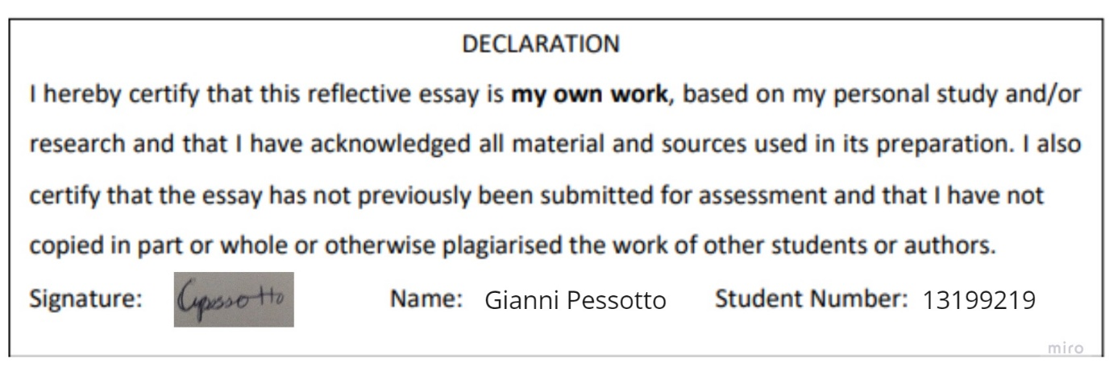

**Assessment 3- Management Consulting-13199219-Gianni Pessotto**

What is the key driver of success in the management consulting firm?

**Executive Summary:**

Success for a management consulting firm has numerous aspects to it that require excellent management skills and relationships with clients. A perfect example of this, has been the process of which my team and I have consulted Charity Bounce over the course of the semester. From having no solutions of any kind, we have given Charity Bounce a means to operate effectively once again whilst the Covid-19 pandemic has raged on and also whilst coming out of said pandemic. Our successes with Charity Bounce are a reflection of how a management consulting firm would approach and perform its operations that would ensure success. The key driver of our success? There were multiple aspects to it. The key drivers of success consisted of effective communication between parties and excellent problem-solving skills. To aid in explaining why and the impact of these two aspects, I will draw from Management Consulting reading list. These two ideas of communication and problem-solving were of the utmost importance throughout this project and are also paramount in real consulting situations.

**P1:**

The lifeblood of management consulting rests in effective, clear communication. Without it, there can be no effective consulting of any client, no matter how easy the solution appears. Communication between the client and the consultants is key as without communication there is no evolution of any solution and as such, ineffective results will be produced and an unsatisfactory conclusion will come to pass. Due to the nature of consultancy being a service, communication and marketability are very high priorities to stand out from the competition. As consultancy is a service and intangible, according to Clark (1995), “the inability of clients to determine quality of (consultants)…” ensures that communication with the client, as a result of no obvious comparative evidence, must be of the highest quality for the client to even select that particular consultancy firm regardless of the firms’ skills. Thus prior to any actual consulting, communication between the firm and potential clients is the key to onboarding the client, without clients, the consulting firm fails. This is solidified as Clark (1995) continues, “(services) are produced and consumed simultaneously” meaning firms performances are very dependent on that initial set of exchanges which can determine the course of a project’s success or failure. This nature of management consultancy is permanent simply due to the nature of the work. This is despite Wileman’s (2002) claims that management consulting has changed far more than ever before. However, how consulting is delivered has changed over time as Wileman (2002) continues saying “Leverage accounts for 90% of the industry… the client generally wants help getting stuff done…”. In this way, clients solve the previous issue while also maintaining a strong relationship that has been achieved through effective communication. This idea is also highlighted in Clark & Kipping (2012), whereby clients and consultants often develop a rapport and that clients can often take on multiple roles through that rapport, which is developed simply by communication between the two parties. As per Wickham & Wilcock (2020), the process of how communication be transmitted is extremely important in ensuring communication is effective. Information must be “presented in some way” and must only “occur if both sender and receiver understand and share the same language used”. Wickham & Wilcock (2020) continues this by detailing just how communication is useful as a business tool that can create a loop of feedback for potential ideas. There are many facets to communication as a consultant that must be considered. The many types of communication, methods when delivering communication i.e., body language, how the other party will receive the information i.e., how they will feel about it and many more. The planning of communication between a client and consultant is something that cannot be simply dismissed as Wickham & Wilcock (2020) detail as there will be a large amount of information, knowledge and ideas produced for the project, which has also been acknowledged by Clark & Kipping (2012). In terms of the course, our team conducted numerous interviews and meetings to establish correct and clear communication not only between ourselves, but with the client and tutor to ensure we were creating a valuable solution for the client. Communication was key in ensuring our solution met the requirements of the client. Therefore, before, during and after a consultation project occurs, management consultants must strive to ensure that the highest quality communications occur to guarantee client satisfaction and excellent project completions.

**P2:**

Consultants are nothing without the ability to solve various issues that arise within the many different companies they consult. The key to consultants’ success in terms of solutions is more than simply problem solving although that is a major piece. As previously established, communication is the enabler for success and can make or break a consultancy firms’ success for any project’s success. A fundamental component of solving the issues a client is facing is simply by having an appropriate approach to problem solving. Basically, the processes a consultant uses to solve the issue. Garrette et al. (2018) provides guidelines on this, as popular models such as 4S, TOSCA and other problem-solving approaches are detailed. As stated by Garrette et al. (2018), “The importance of a good problem statement can’t be overstated” which coincides with Einstein’s famous saying, “If I had an hour to solve a problem, I’d spend 55 minutes thinking about the problem and 5 minutes thinking about the solutions.” (Garrette et al., 2018). A flawed problem definition is just as harmful to project success as much as erroneous communication is. This is all the more reason for consultants to have excellent problem-solving skills as according to Wickham & Wilcock (2020), management consultants and their firms often take on most if not all responsibilities similarly to a manager would. From this perspective, consultants become managers and the best managers are already somewhat skilled at problem-solving. This is exactly as Wickham and Wilcock (2020) detail consultants and their duties during the client-consultant interaction. Consultants are described as “The consultant is a manager… will take on many if not all roles…” Therefore, as a consultant, it is normal to undertake managerial responsibilities within the client organisation which without good problem-solving skills will result in disaster. This is true regardless of what mode the consultant is hired for, whether it be ‘seagull consultants’, ‘leverage consultants’ (Wileman, 2002) or if the consultant takes on an ‘expert’, ‘doctor’ or ‘process consultant’ (Wickham & Wilcock, 2020) role for the client. As consultants must have adequate problem-solving skills, this leads to new situations that consultants may have little expertise or knowledge of. In this case, a large piece of the ability to problem solve comes in the form of adaptability. Adaptability aids consultants in determining solutions for the issues that clients contract consults for. As mentioned, consultants take on many responsibilities, however, the situations and technologies they find themselves in may be new or different to what has been established throughout other clients’ businesses. With adaptability comes analysis skills, which enable consultants to find cause and effect and act on it. As Wickham & Wilcock (2020) state, a consultant must “offer the business the ability to move from where it is now to somewhere… better”. Without this prospect, consultants will not succeed as they did not adapt to the new situation and as such will not be able to solve the clients’ issue/s. This sentiment was true throughout the course of the consulting assignment our team undertook. We came up with various solutions based on the clients’ communicative needs before fleshing out one that met requirements set by the client. Due to the new experience, our team had to adapt to the new situation and use analytical skills to ensure that the solution we arrived at, was a solution that was fulfilling for the client. Therefore, without adaptability and overall problem-solving skills, consultants will never succeed within the industry as they are just as vital to success as communication and onboarding are.

**Conclusion:**

For a management consulting firm, there is no single key driver of success. Rather, success consists of many aspects that together, form the consultant’s ability and therefore, its success. Consultancy firms’ success is reliant on the consultants themselves and as such the consultant must have the necessary skills to create value for clients. Throughout the semester, our ideas of a solution to the issue posed to us by Charity Bounce took many forms. However, after much communication and application of problem-solving skills, we were able to create the solution that the client valued and one they could implement despite our collective inexperience in this field. As a result of the experiences this subject offered and studying consultants, it is clear that communication and problem-solving are the keys to success for a management consultancy firm.

**References:**

Clark, T. (1995). Managing Consultants: Consultancy as the Management of Impressions. 41-65.

Garrette, B., Phelps, C. & Sibony, O. (2018). Cracked It! : How to solve Big Problems and Sell Solutions Like Top Strategy Consultants. 1-274.

<https://web-s-ebscohost-com.ezproxy.lib.uts.edu.au/ehost/detail/detail?vid=0&sid=8dc63f6b-acaf-4d38-ade2-8a412ef7a697%40redis&bdata=JnNpdGU9ZWhvc3QtbGl2ZQ%3d%3d#db=nlebk&AN=1828611>

Kipping, M. & Clark, T. (2012). The Oxford Handbook of Management Consulting. *Oxford Handbooks Ser.*, 1-579. <https://ebookcentral.proquest.com/lib/uts/detail.action?docID=6461211>

Wickham, L. & Wilcock, J. (2020). Business and Management Consulting PDF EBook: Delivering an Effective Project. 1-332. <https://ebookcentral.proquest.com/lib/uts/reader.action?docID=6118339>

Wileman, A. (2002). Confessions of a consultant. *Management Today*, 32-37. <https://www.proquest.com/docview/214770430/abstract/D5EE0BC1AB904AFDPQ/1?accountid=17095>